Do you farm sheep in England, Wales, or Scotland?

We invite all GB sheep farmers to participate in the

SHEEP SCAB SURVEY 2021

whether or not you have experienced sheep scab in your flock before.

The survey aims to understand opinions, experiences and decisions made by British farmers when managing sheep scab. Take 15 minutes and share your opinions to be in for a chance to win a fantastic gift! All information you share is confidential, and any information you provide will be used in research anonymously.

To participate, please follow the link:

https://nottingham.onlinesurveys.ac.uk/sheep-scab-survey-2021

The survey is conducted by the University of Nottingham as part of a wider collaboration with the Moredun Research Institute, University of Bristol, University of Glasgow, APHA, SCOPS, BioSS and the support of key industry stakeholders. It is funded by the Veterinary Medicines Directorate.
All participants get chances to win an Apple iPad or £100 voucher to spend how you wish!

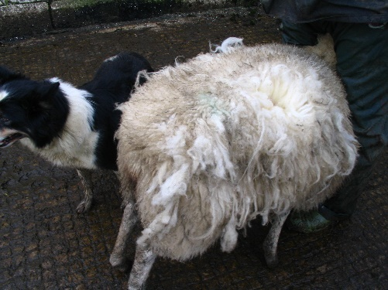
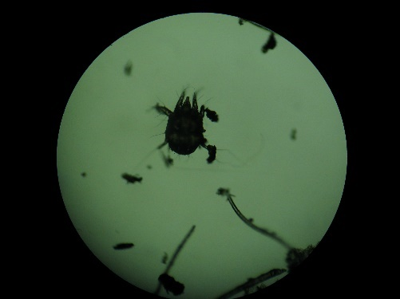
WIN

one of three chances of a gift:

1) Apple iPad
2) £100 voucher
3) £100 voucher

